## *Connect Four Game Project*

Project description-UML diagram-Screenshots from the Runtime

### Team Members:

1. Ahmad Khaled
2. Kareem Ashraf
3. Mustafa Medhat
4. Abdelrahman El- Antably
5. Ahmed Hesham El-Tohamy
6. Abdelrahman Diaa

## Bioinformatics Department

### Second Year

### Connect Four Game

Connect Four (also known as Captain's Mistress, Four Up, Plot Four, Find Four, Fourplay, Four in a Row, Four in a Line and Gravitrips (in Soviet Union)) is a two-player [connection game](https://en.wikipedia.org/wiki/Connection_game) in which the players first choose a color and then take turns dropping colored discs from the top into a seven-column, six-row vertically suspended grid. The pieces fall straight down, occupying the next available space within the column. The objective of the game is to be the first to form a horizontal, vertical, or diagonal line of four of one's own discs. Connect Four is a [solved](https://en.wikipedia.org/wiki/Solved_game) game. The first player can always win by playing the right moves.

Classes :

Board :

There are 12 functions :

1.AddDisk:

Load the disks to the board,adds a new disk when a player plays

2.whoPlays:

Choose who will play from player one or player two.

3.CountDisksIn:

Check if a certin cell in the board is empty.

4.HighLightCell:

Mark the winner coloumn or Row when a four disks with the same colour are connected together.

5.Check coloumn:

Check if Four Disks of the same colour are connected together in a certain coloumn.

6.Check Row:

Check if Four Disks of the same colour are connected together in a certain Row.

7.Check Diagonal:

Check if Four Disks of the same colour are connected together in a the diagonals.

* TopRight : check four cells in the board in the direction of the Top right of the last played disk.
* DownLeft : check four cells in the board in the direction of the down left of the last played disk.
* TopLeft : check four cells in the board in the direction of the Top Left of the last played disk.
* DownRight : check four cells in the board in the direction of the Down Right of the last played disk.

8.Diagonal:

Adds the two counters in the (TopRight,DownLeft) or (TopLeft,DownRight )functions and check if any player won in any diagonal.

Disk:

This class loads the empty white disk.

BlueDisk:

This class inherits from the ‘ Disk ‘ class and loads a blue disk.

RedDisk:

This class inherits from the ‘ Disk ‘ class and loads a red disk.

AI:

This class determines at which move the Artificial Intelligence will play.

Easy Difficulty&Normal Difficulty

**Screenshots for running the program**

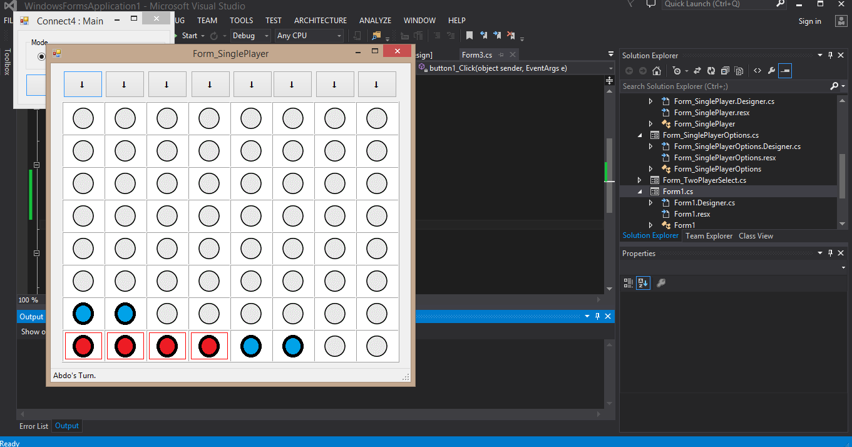

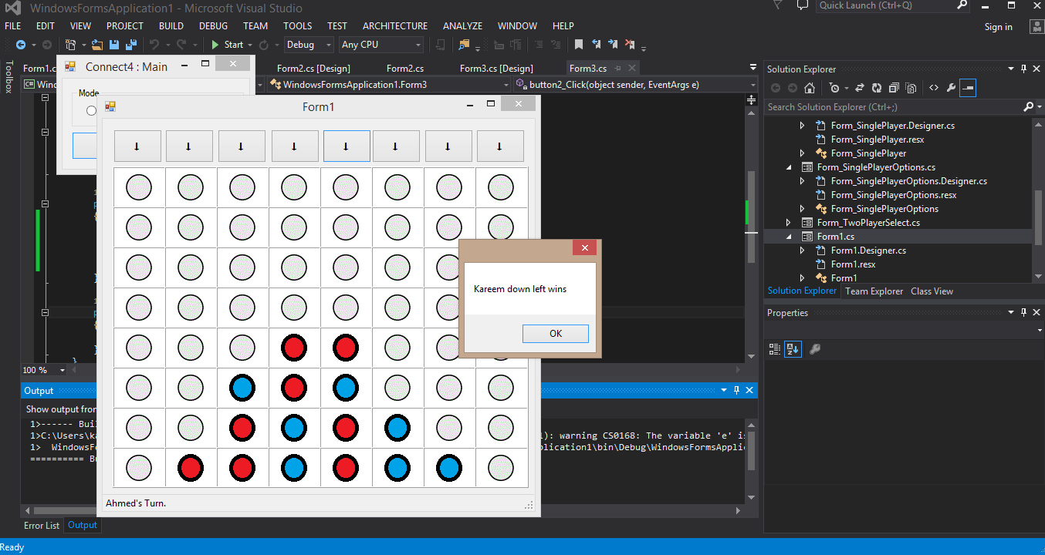

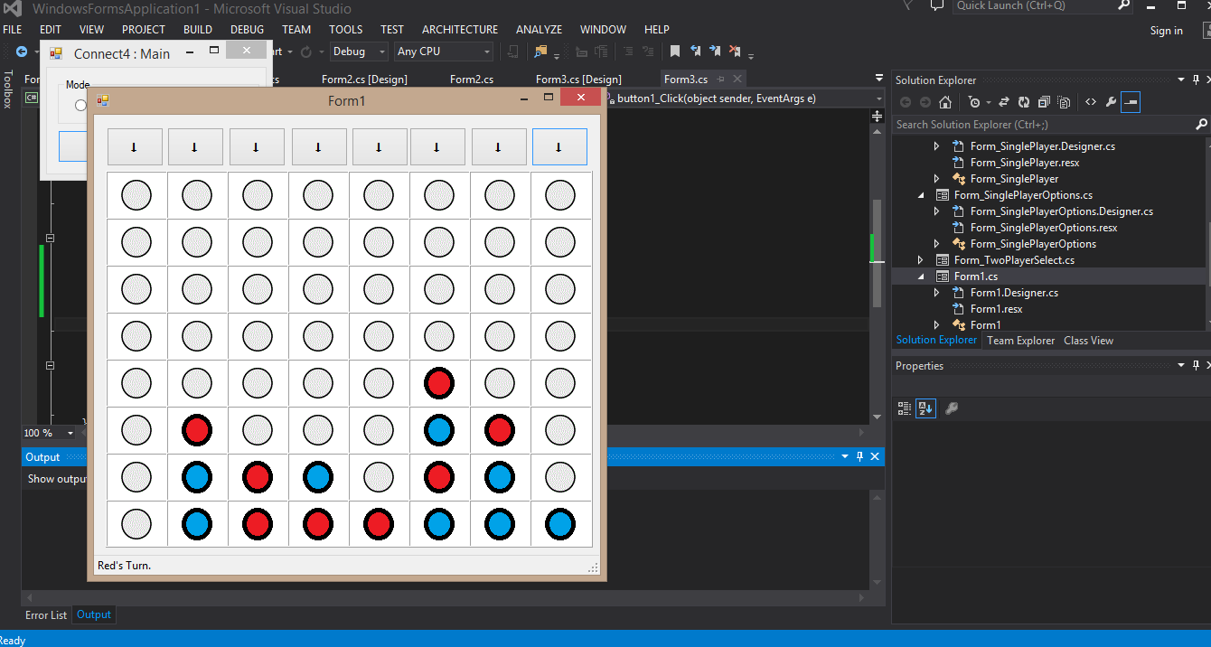

***UML Diagram***

